Name |  |  | DOB
Room |  |  | House:
APPLY PATCHES AS DIRECTED BY PATCH INSTRUCTION ( for example do not put back in same place for 14 days ) Mark with an X the site used
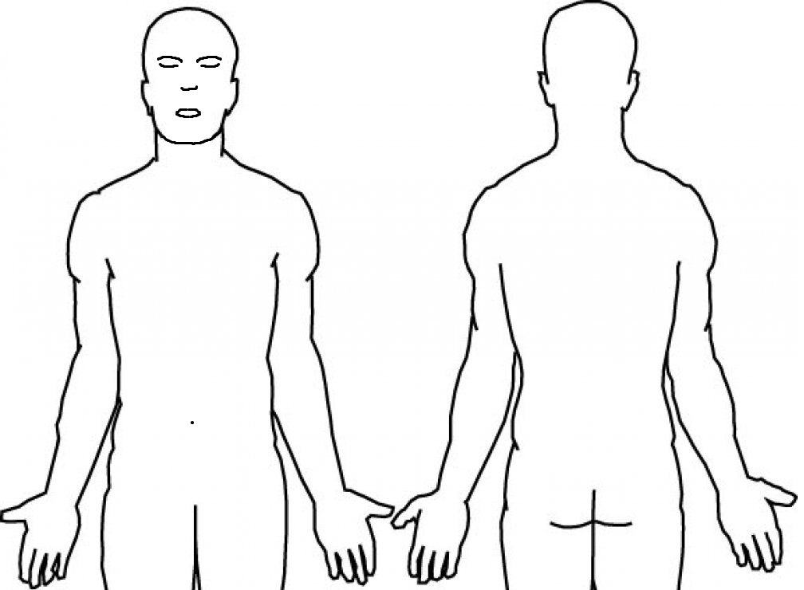 |  | Patch Name:  Date applied:  (new patch) Initial:  Date removed: Initial:  (previous patch)
Patch Name:

Date applied:
(new patch) Initial:

Date removed: Initial:
(previous patch)
Patch Name:

Date applied:
(new patch) Initial:

Date removed: Initial:
(previous patch)
Patch Name:

Date applied:
(new patch) Initial:

Date removed: Initial:
(previous patch)

Name |  |  | DOB
Room |  |  | House:
APPLY PATCHES AS DIRECTED BY PATCH INSTRUCTION ( for example do not put back in same place for 14 days ) Mark with an X the site used
Patch Name:

Date applied:
(new patch) Initial:

Date removed: Initial:
(previous patch)
Patch Name:

Date applied:
(new patch) Initial:

Date removed: Initial:
(previous patch)
Patch Name:

Date applied:
(new patch) Initial:

Date removed: Initial:
(previous patch)
Patch Name:

Date applied:
(new patch) Initial:

Date removed: Initial:
(previous patch)

